EXERCISES
1. Look at the pictures. Look at the letters. Write the words:
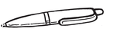 | 1.pne  ……pen…. |  | 6. snwdciha  ……………………
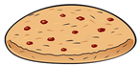 | 2. ckieoo  …………………… |  | 7. dnikr  ……………………
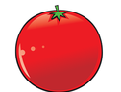 | 3. totmoa  …………………… | 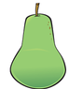 | 8. erap  ……………………
 | 4. annaab  …………………… | 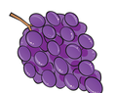 | 9. aesrpg  ……………………
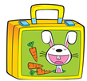 | 5. ulnboxch  …………………… |  | 10. iec-ramec  ……………………
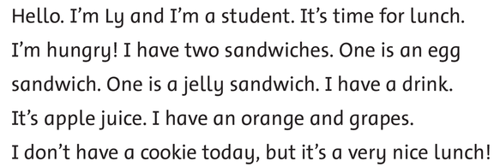
2. Read and write answer yes or no:

- Ly is a teacher. No
- She has two sandwiches. ___________
- She has an egg sandwich. ___________
- Ly has orange juice. ___________
- She has a cookie today. ___________
3. Look and write:
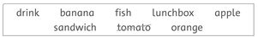

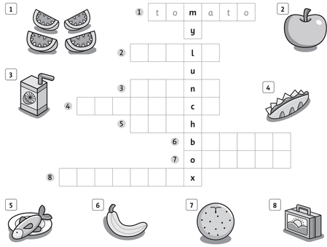

Answer key
1. Look at the pictures. Look at the letters. Write the words:

2. cookie
3. tomato
4. banana
5. lunchbox
6. sandwich
7. drink
8. pear
9. grapes
10. ice-cream

2. Read and write answer yes or no:
1. No 2. Yes 3. Yes 4. No 5. No
3. Look and write:

1. tomato
2. apple
3. drink
4. sandwich
5. fish
6. banana
7. orange
8. lunchbox

